**Assignment:**

**(a)**

Consider the following “worker” table

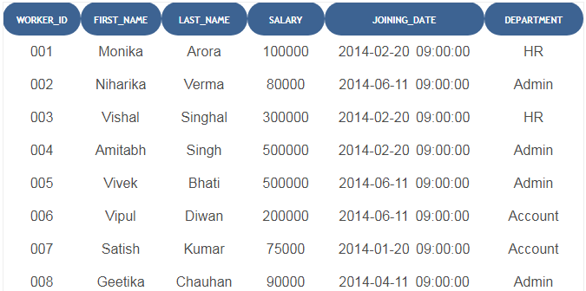

Write the SQL queries according to the criteria given below

1. Write An SQL Query To Fetch The Count Of Employees Working In The Department ‘Admin’.
2. Write An SQL Query To Insert a new record in the worker’s table.
3. Write An SQL Query To Update Salary to 60000 if Worker_ID is 005.
4. Write An SQL Query To delete record of Vipul.
5. Write An SQL Query To Print Details Of The Workers Whose FIRST_NAME Ends With ‘A’.

Write An SQL Query To Print All Worker Details From The Worker Table Order By FIRST_NAME Ascending.

**(b)**Define a queries for the Books database. Provide the following predefined queries in C#.

a) Select all authors from the Authors table.

b) Select all publishers from the Publishers table.

c) Select a specific author and list all books for that author. Include the title, year and ISBN number.

d) Select a specific publisher and list all books published by that publisher. Include the title, year and ISBN number.

e) Provide a query that insert new record of author and publishers in tables.